Hiroshima Teenage Soldier Saw
Reiichi Omura
The third grade

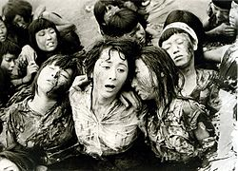
from movie "Hiroshima" (1953)

Commentary
Madness and Lethal weapon of the war Nobuhiro Hagiwara
Aug 2014

Reiichi Omura
“The Third Grade”
~the Misery of An Atomic Bomb in Hiroshima~

At 8:15 on August 6th in 1945, the first Atomic Bomb was dropped in Hiroshima. The next day, August 7th, it was easier to live outside around 17:00 than that time of yesterday. I was working hard helping an extremely large number of patients, cleaning up fragments of concrete blocks and recovering a large number of dead bodies. I had just come near Ujina Port walking 5 km after I was off-duty as a security guard at Marques of Asano and was ordered to work for a hospital at Ninoshima Island.

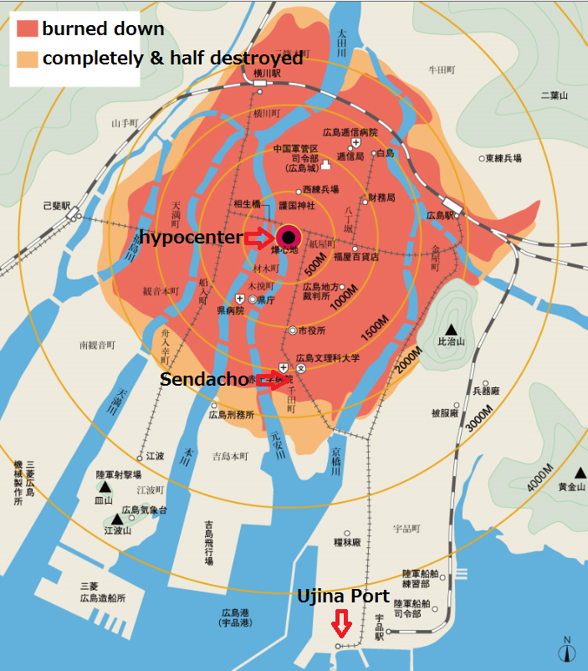
Hiroshima radiation exposure map

Kobayashi, who was a young military cadet, looked very tired, but followed me silently. When I turned to him, he smiled back to me with his dirty face of sweat and mud. He looked like he was crying. Maybe I was, too. I encouraged him,
“We will arrive at Ujina Port soon.”
Just after that, someone said to us,
“Help us, please.”
It was a small husky and broken voice. Every time we were asked to help, we answered,
“You should go to Ujina, there are some relief parties who can help you. We are also trying to get there.”
Sometimes we would show the way. That was why we wasted time to getting to Ujina.
A woman said,
“We hear we can have medical care in a hospital in Ninoshima when we get to Ujina. So we tried getting here, but we haven’t ridden ships since morning because there are enough boats.”
The woman who was asking for help wore tattered clothes, the same as other victims, walked in bare foot, and had her feet caked with gore and mud. Also, she had a bad laceration wound on her forehead. She was carrying a child with a bandage wrapped around its face on her back. I could see their eyes how much they needed to be helped. They must have asked for help many times at the port.
We said,
“Wait here a moment, we will go and see what’s happening.”
She answered,
“No, I am coming with you.”
She must have been afraid that we would leave them. There was no doubt what she thought. We went to the port.

I was very surprised to see the port. There were huge numbers of victims waiting for ships. Some people were crying or shouting for help, others were looking at sea in a vacant-eyed stare. And there were not enough boats for so many people to ride on the ships since morning.
I found the reason why she had not ridden a boat.
The woman asked me,
“We can’t ride, can we?”
I couldn’t say,
“No,” looking at woman’s eyes.
I answered,
“I’ll try my best. Wait here until a boat is coming.”
She might be so pleased that tears flowed ceaselessly on her cheeks. She sat down and wiped her tears with her dirty hands, so her face became dirtier and dirtier by mud.
“Thank you very much. We can live.” She said with a quiet voice.
“We will be sure to help them.”
Mr. Kobayashi and I made a firm resolution each other.
After a short time, she recovered her presence of mind. She said to us with a strong voice,
“Thank you so much. To tell the truth, I want to save another 7 children. Would you help them, too?”
Mr. Kobayashi and I decided to help as many children as possible. I asked him to contact with me when a ship came and we moved to comfortable place.

I asked a woman some questions. She answered me that her name was Sato and she was a teacher in elementary school. She had class 2 of 3rd grade. The child on her back was in her own class.
On August 6th, all pupils in her school gathered in school yard. Of course 40 pupils in Sato’s class gathered, too.

Ms. Sato said to me,
“An Atomic Bomb broke them up in a flash at 8:15 in the morning. I could not express at all what was happening. When I came to myself, school building burned briskly. A large number of pupils and teachers were falling down in the yard. Some wounded pupils came out under people fallen down. Every people was so cruelly wounded that I could not bear to look at them. Their clothes looked like sea weed. Their faces, hands and feet except covered with clothes were badly burned. Some people were crushed beneath fragments of concrete and others got a splinter in their bodies. Some parts of their bodies were torn up. That was a hell on earth. I looked for her 40 pupils frantically. Half of them were killed instantly. Others were about to breathe their last even if they were alive.
A man shouted,
‘Hurry up! Leave the yard immediately.’
Strong flames shot out from the school building. Flames looked like animal and moved by wind.
I said to my pupils,
‘Leave here. Follow me.’ I took some hands around me and escape. I didn’t know where we had gone.”

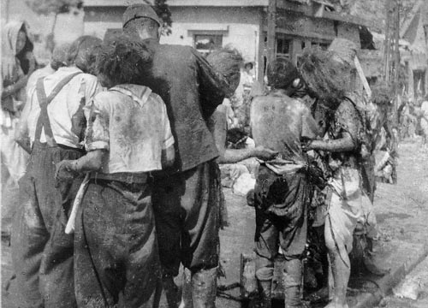
3 hours after exposure, photo at 2 km from the hypocenter (by Yoshito Matushige)

She continued,
“Though we want to give up because we cannot find the way to escape from being enveloped flames many times, we kept hoping till very end. When we reached river, we thought we saved ourselves. I ordered my pupils to go into the water.
It was comfortable for us to have cold water in river, and the dirty water healed our irritated throat. My pupils gathered in the river, but they were eight.’
Some left in the school yard because they could not move. Others lost their way.
‘We are saved. Hold me tight not to lose.’
I cheered my pupils, also cheered myself strong.
Every time wind blew fire on the water in the river, then we dove into the water. When we surfaced and fire blew, we were downing.”
Ms. Sato told me that a large number of people came to the river and dove into one after another to escape from fire and heat. Ms. Sato and her pupils held each other not to flown.
Her watch was broken and she didn’t know when it was. Nobody knew what to do.

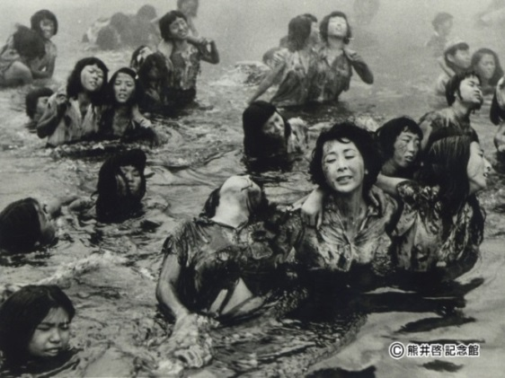
from movie “Hiroshima”(1953)
She continued,
“The wind blowing on the river became cool suddenly. The rain fell on her cheeks. When I spread my arms, the rain hitting me on my arms and cheeks made me feel comfortable. But it was completely different from what it had been.”

The rain was called “the black rain: it included a large quantity of radiation. Every people beaten that rain got an A-bomb disease and was killed within a month, even if they weren’t directly exposed to radiation.
As the black rain fell, fire on the riverside became small. Ms. Sato and her pupils rose on the riverbank and took a rest. Another people were also rising one after another. They don’t look like human being, but like brown rats. Each people wouldn’t move after they rose from the river and fell down.

Ms. Sato also fell down and fell asleep, but fortunately she woke up feeling cold. It was night. She woke her pupils around her up and made them move near the small fire. Then they stayed outside over night. The morning on 7th, she heard she could got to Ujina and be saved. She managed to come here with her pupils. There were great many people to be saved and she didn’t get help.

I found her 7 pupils waiting for her at the edge of the eaves whose house was burned but was not completely fallen down. They looked as if they weren’t human being. They called Ms. Sato, standing and walking closely to her. Their skin of hands were slightly melted and peeled by burnt. The skin was hanging from top of fingers. Some pupils crawled to her with serious wounded feet.

Ms. Sato asked me,
“Would you please give them water?”
I gave her my water bottle. She got it carefully, and gave water to her pupils.
Ms. Sato said to her pupils,
“Share this water little by little.”
Each pupils wanted to drink water all of them. But Ms. Sato carefully looked at them taking just a mouth, a pupil on her back could drink the last drop but she couldn’t.
I found them hungry seeing their face unsatisfied. They escaped from fire all day long and didn’t eat anything. I gave them bread which I got for emergency provisions. I shared a bit of bread with Ms. Sato and her pupils. They nibbled it greedily. I gave a sugar ball drop to some pupils who didn’t eat bread. Ms. Sato and her pupils looked fine. After that, I led them to the port.

Mr. Kobayashi, my fellow cadet, showed me good information at the port. My group of army sailed to bring food for rescue teams by a big military boat at a military pier. They were going to stay for two hours. We soon went there, and found two cadets, who were two years younger than I, patrolling. We told the truth. They asked us to operate the ship. As we agreed with it, they admitted we could sail to Ninoshima. We soon took about one hundred patients and left Ujina for Ninoshima as soon as possible.

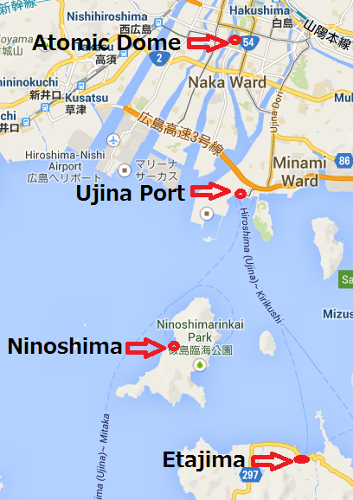

A large number of patients were filled with in a hospital in Ninoshima. Some patients were sleeping on the beds, others were collider. Some were in the entrance, others were in the garden. We took Ms. Sato and her pupils to a washstand besides resting room and made them sit on some blanket and then calm down.

Mr. Kobayashi and I joined nursing team, and sometimes called on Ms. Sato and her pupils when we took a break. When I took some medicines for them, Ms. Sato wiped children’s faces with water from a faucet. I disinfected wounds of hers and her children’s. It was too difficult to wipe away dried gore. Especially, it was hard for me to cure her because a cut wound on her forehead began to suppurate. I could do nothing. I ask some doctors to cure her, but all doctors were busy many operations, caring worse patients.

20:00 on 7th, we managed to receive meal. That was what we could see a few grains of rice, millet and foxtail millet in a kind of thick soup. There was no dish or cup, so all kinds of containers (like washbasins and buckets) were used as dishes and cups. I managed to get as many grains as possible in my meal gear and took it to her.

When I apologized to them for being late for giving meals, I found Ms. Sato and her pupils cry. I held my breath to see the sight.
Ms. Sato said to me,
“Two pupils have died.”
When I was ready for meals for Mr. Sato and children, 2 pupils have silently breathed their last. They were the 2 pupils gotten serious burnt. She took one and I did the other.
I asked Mr. Kobayashi to get some candles and incense sticks for the two, but he had also fallen and been taken back to team for exhaustion.

23:00 on 7th, as I was admitted to slight sleep, I tried to sleep near them. I was about to fall asleep, a voice awoke me. That was Mr. Sato’s. She shouted.
“Cheer up, Shizu-chan.”
The pupil breathed with difficulty. She said to Ms. Sato,
“Good bye, Mr. Sato. Good bye.”
She breathed her last.
Ms. Sato shouted again to me,
“Tatsuko has turned for worse.”
Ms. Sato held a hand, and it was one of her pupils called Tatsuko. As I held it, it was cold. On the other hand, Mr. Sato’s hands were very hot. Her forehead was too hot to touch. I wrapped Tatsuko with blanket. I cooled Ms. Sato’s head with cold wet towel.
Tatsuko wanted to tell something, and she called a very small voice,
“Ms. Sato. Ms. Sato….”
Ms. Sato managed to whisper into Tatsuko’s ear.
“Soon, I will follow you. Tatsuko….”
I hurried to awake the pupils up and said,
“Ms.Sato and Tatsuko-chan is dying. Please cheer them up.”
Children shouted one by one,
“Come on. Don’t give up.”
Ms. Sato held each pupil’s hand and said to them,
“I will, but you will do your best and live whatever may happen.”
And she also said to me,
“Please take care of them, please….”

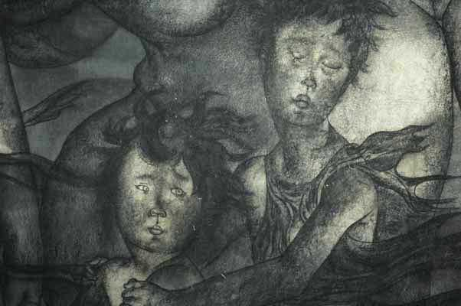
from the Hiroshima Panels “Takeyabu” by Iri Maruki and Toshi Iri
Ms. Sato and Tatsuko died and their hands became cold. A Teacher and her pupil held their hands and must have passed away together. There was no description for the left children. I could only stand there, looking at the children.
One pupil shouted,
“Ms. Sato, wake up please.”
One shouted,
“I will follow you soon.”

I decided to look for 4 left children, but it was finally in vain.

They died one after another till the sun rises.
Every child called their mother and breathed their last after Ms. Sato died. The last child, Haru-chan, called her mother and said to me,
“Thank you very much,
I never forget the voice forever.

My fellow cadet, Mr. Kobayashi, got high fever, explosive diarrhoea and bled hardly from the nose. He finally died of an acute A-bomb disease in August 14th, just before the anniversary of the World War II. His death was called a glorious death in Japan because he worked hard in Hiroshima just after dropped an A-bomb. After he died, he was promoted to second lieutenant.

It was not until after the war that I was heard that the new kind of bomb was the first A-bomb in the world.

Post Script
This is the first time that I write about an A-bomb in Hiroshima. I have tried to forget the horrible days, but I won’t. I always remember that day. I sit and write about it by PC because I never forget that day when a large number of my fellow soldiers died in an instant in Hiroshima.

I had belonged to a Wakashio suicide (special) attack team 53, in Kounoura military base in Edajima. Then I was commanded that I should change to a rescue team for Senda-cho in Hiroshima on August 6th. I didn’t remember clearly whether I saved people or escaped myself in such a terrible situation. I didn’t exactly know how many people died and how many wounded people I could help were there at that time. It was a pity that my mother, daughter and son also died in an A-bomb by turns. It was just the same time as the teacher and the pupils.

In Ninoshima, as a member of the rescue staff, I took off name tags from dead bodies and buried them by interments. That was why the preparation for funeral wouldn’t be completed in time. The teacher and the pupils must be there.

I have always been wondering why I am alive. I wrote a comment on the last page in my military diary.
“I was commanded that I should go and rescue to Senda-cho in Hiroshima.”

By Ohmura Reiichi
Commentary
Madness and Lethal Weapon of War
~about Hiroshima, Pacific War and Teenage soldiers, the cause of death of Japanese soldiers~
Nobuhiro Hagiwara

Kenzaburo Oe, who won the Novel Prize for Literature in1994, describes in ‘Hiroshima Note (1965).’
“Hiroshima city is hard evidence to not only power of nuclear weapons but also a far north evidence for human tragedy of it. The truth of the human tragedy about it must be known to many people clearly as well as that of the Auschwitz.
We can know the truth by ‘The Third Grade.’
“People who have kept living in Hiroshima start writing or telling about the human tragedy instead of being silent about an A-bomb or forgetting it. It is just an extraordinary effort,”
Mr. Oe also emphasized, ‘The Third Grade’ is a valuable document written with "extraordinary effort."

Hiroshima is the place for one of the discriminate slaughter by America. USA started attacking Tokyo and other big cities to destroy. An A-bomb is the ultimate weapon made by war madness.
Mr. Ohmura was a member of a suicide attack team. When we look for a death during the war, we can know the extraordinary madness: We were not treated as a human being. Some soldiers attacked military ships with plane, some did in torpedo, or another soldiers rushed in carrying explosive.
Also, people in battle field must not surrender to the enemies, so people had to commit suicide before they caught. Some researchers say that it was a command by military.
We must not repeat the tragedy in Hiroshima, have no nuclear weapons and renounce war.

About Reiichi Ohmura In1999, Mr. Ohmura died of colon cancer in our hospital (Asahikawa Hokkaido). He was a teacher in elementary. He worked in Hiroshima city just after an A-bomb was dropped. He worked as a member of rescue team and also he was exposed to radiation. Before he died, he wrote “The Third Grade” in 1985. It shows the truth of the first A-bombing in Hiroshima. This article is recorded in a small private magazine called “Chubetsubuto” in Asahikawa Chubetsu Elementary School.
Once I worked in the hospital and was in a charge of responsible for examinations for A-bomb victims. I met Mr. Omura as a patient, but he never told me about an A-bomb in Hiroshima.

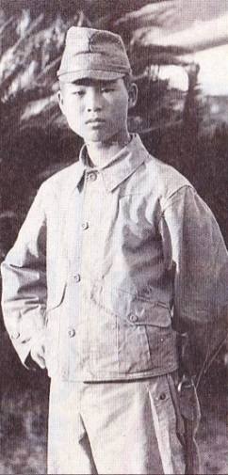 I changed to Asahikawa Clinic which belongs to the same association and met his wife as a patient in 2013. I asked her,
“I look for some documents which your husband wrote about the day when he had worked in Hiroshima.”
She answered and showed me,
“He has never told me about that, but in fact, he wrote this document.”
That is “The Third Grade.”

“The Third Grade”
In his document, we can find the truth between August 6th and 8th in Hiroshima. We can understand a symptom of an acute A-bomb disease. An A-bomb brought high heat ray, strong blast and strong radiation. It is said that the ground zero, the center of explosion, was about 3000 ~ 4000 degree centigrade. 90 ~ 100 % of people, who was exposed to radiation within 1 km from the bomb and got severe burnt, were killed in a week. According to the research record on August 10th, 1946, 122,338 people were killed (include missing people).

Now in 2013, about 202,000 people exposed to radiation have A-bomb victims notebook according to the report by the Ministry of Health, Labour and Welfare. 8,552 patients are designated victims of an A-bomb. Only about 4.3% of the people have been designated because the only people that directly exposed to radiation could be authorized and could have the special care. The system has many problems and it should be renovate for an A-bomb victims.

I attended a conference by Kamada, an emeritus professor in Hiroshima University and studies haematology, in Sapporo the other day. He indicated that “The Third Grade” was the precious note for an acute A-bomb disease. According to the post script, Senda-cho was located within 1.5km from ground zero.
His fellow, Mr. Kobayashi went to Hiroshima just after an A-bomb was dropped, saved people. He got high fever, had explosive diarrhoea, bled hardly from his nose and finally died in 8 days since he entered. In fact, he was exposed to radiation. This was the best example for ‘indirect exposure to radiation.’ For a long time, it has been said that people who entered Hiroshima just after an A-bomb dropped were not exposed to radiation. We can discredit about this explanation by “The Third Grade.”
Though Hiroshima was not a battle field, a large number of children, women and other innocent citizen were killed in an A-bomb. Some people were disappeared in a flash. Some were charred bodies like charcoal. Many survivors also have lived severely for a long time
We have always appealed,
‘We never forget Hiroshima A-bomb, and don’t need nuclear weapons forever.’
Actually, bombing in Chongqing in China by Japanese army was a model for bombing in many Japanese cities by the US’s. A lot of incendiary bombs were used for both bombing. Those were so called a great massacre. Though an attack for private citizens is prohibited by international law in time of war, there has been this kind of massacre for a long time all around the world after the World War II.
Many kinds of lethal weapons were invented during the war: those were incendiary bomb, napalm bomb and A-bomb. Also, there are Agent Orange, Cluster Munition and depleted uranium munition. Human made inhumanity weapons during the war and killed a large number of innocent people. Madness of war has made many kinds of lethal weapon.
Taking advantage of an A-bombing in Hiroshima, people all around the world have hoped no nuclear weapon and war. This hope is exactly what Article 9 of the Japanese Constitution that renounces war is.

Pacific War and Teenage
Reiichi Ohmura applied to military cadet and went into the Japanese Army at the age of 16 in1944. He was assigned to Etajima military base in Hiroshima. It was called the 46th Wakashio suicide attack teams. He entered the center of the explosion and engaged in working of relief and the guard. “The older soldier” is inscribed was a 17.
There were 6 people in his family: his parents, an older sister and two younger sisters. He applied in the military, and his poor family immigrated to Manchurian. His father was called up and entered the army. Finally, he was killed in the war just before the end of the war. The older sister died of disease there. After the end of the war, his mother came back to Japan and she died of disease, too.

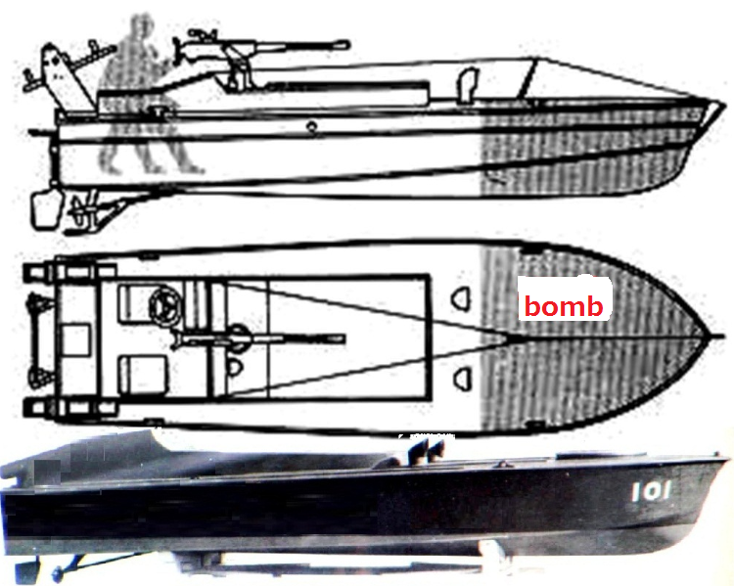
Kamikaze boat by “Image of MIYA”

Mr. Ohmura worked as a teacher at an elementary school after the war. He took an operation for sigmoid colon cancer at the age of 64. He died of metastatic lung cancer when he was 70.

In 1944, Japan lost the command of the air, of the sea, had almost one of the airplanes and the vessels to attack anymore. Then Japanese army called for volunteers as the special army cadet. It was 4,230 numbers. For them, communication boat named Kamikaze boats had been prepared. The boats were made of thin plywood with a depth bomb.

Kamikaze boat was just adopted in August. 1944. It was produced 6,197 ships by the end of the war. Teenage soldiers were gathered as suicide attack soldiers from the beginning.

My uncle, Kenkichi Kawamura, applied to the Imperial Japanese Navy’s at 16 in 1943. As a Kamikaze suicide attack pilot, he received sortie order on August 17, but he was not killed because it had already ended the war 2 days before. There were 622 enlistment classmates, 290 of them, consumption rate was 46.5%, were killed in the war.
The sortie of the Kamikaze suicide attack unit continued from Oct. 1944 to the end of the war.

The core of the boarding soldiers were occupied a Kamikaze pilots. They hit enemy ships by airplane with themselves and bombs. They got the half fuel and could not return.

It was a terrorist attack by the Japanese navy assuming the own death.

Recently, I have heard about the war in the interval of the medical examination and found 10 teenage soldiers name. One of them applied at 13 years and 10 month old in the army force and became a communication soldier.

It is not known how many teenage soldiers were there. There was a document that navy employed flight soldiers more than 110,000. Many teenagers were trained as soldiers and were sent to the battlefield.

We must know the extraordinariness that boys like Reiichi Omura and Kenkichi Kawamura were called up as the suicide attack soldiers who promised death surely. We can know madness of the war when we chase the real death of the Japanese soldiers.

The Real death of Japanese Soldiers at the World War II
In the World War II, known as the Pacific War, started on 8th of December. 1940 and ended on 15th of August.1945. 2,300,000 soldiers of Japanese were killed in the Pacific War.
The death in the war is abnormal generally, but that of soldier of Japan is extreme.

Suicide, Kamikaze Attack death
There were kinds of suicide attacks, such as plane loaded bombs were known as Kamikaze Special Attack Units, motorboat loaded bombs, torpedo and so on. The body count of suicide attacks was approximately 4,000 men.

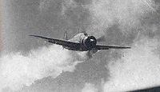
Kamikaze just before rush to the USS

Death from drowning
The dispatch of the soldiers to the Southern battle line was carried out by ship, but Japanese troop-ships were attacked and sunk in succession by U.S submarines. Many soldiers were drowned over about 400,000 men, include of army over 191,000 army, 122,000 navy, 61,000 shipping stuffs. The total amount was 400,000 included private people and some comfort women.

Death of Starvation
Most strategies of the Japanese military ignored the supply such as weapon, ammunition, and fuel or food. Especially, they had to get food by self-sufficiency at the battlefront, and they were led to much death from starvation.
The war death of an disease at the battlefield was virtual death of starvation in Japanese military.
About 2,300,000 people were killed in the war. About 1,400,000 people died of starvation. This rate is 61 %.

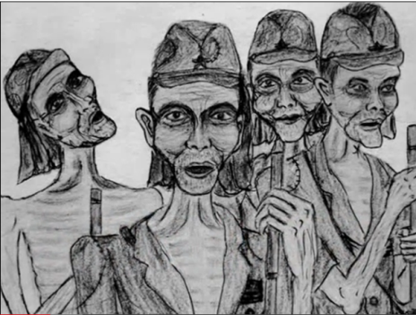
Western New Guinea Berau isthmus comrades Association journal No.12

Compulsion of the suicide and killing to sick and wounded soldiers
The measures of sick and wounded soldiers at the time of the withdrawal have already been decided by the order of the military without the doctor diagnoses. According to the special battle law, the army surgeons or combat medics carried out the treatment, compelled to suicide or kill them.
It was the national crime, and the army surgeon took the role of a practice criminal. Neither country nor Japan Medical Association has been apologized for the crime after the war.

Death by Banzai charge
The Japanese military did not accept the choice of the surrender to soldiers.
Without food or weapons to fight directly, they fixed a bayonet on 38gun made in 1905, and they went to the enemy’s land while appealing for Banzai by night. It means Banzai charge
The U.S Army beat Japanese soldiers picked up with flare by overwhelming heat.
The death by enemy bullet was not glorious death, but almost forced a kind of suicide attack.

In order to win the war, we have to kill people in enemy’s side. We must not recognize a partner as a human being to murder a person. We cannot kill persons, having reason and humanity. The society which lost reason drove not only the enemy but also own soldiers and children to extraordinary death.

By the madness of the war, Japanese soldiers were handled like one of the weapons without watching people as human being. Soldiers were sent to the battlefield as a “weapon.” It may be said that they were killed by their nation. The aberrant death of them tells us that we must renounce the war.

From the country renouncing the war
to the country going to the war.
From an experience of the war, Japan has walked with the new constitution to declare war renunciation. That is why Japan has never done the war for 69 years after World War II.
But the current administration, Abe Cabinet, is going to make “a country going to war.” It established “Official Secrets Act” that takes people’s right to know last year. This spring, they abandoned “Three Principles on Arms Export” and planed the promotion of the war industries. And in the last July (this year), the government passed a Cabinet resolution. Mr. Abe stretched the Article 9th in his favor. Then he wants to make it possible to get the right to send Self-Defence Forces to battlefield. Japan is now going to walk “a country going to war” and to lead to “Nation with the Military Power.” It leads to the course of “Nation with the Nuclear Weapon.”
As a doctor opposing the nuclear war, I will make outright resistance and must do all I can to keep “the country renouncing the war.”

- ☆ ☆ ☆ ☆ ☆ ☆ ☆ ☆ ☆
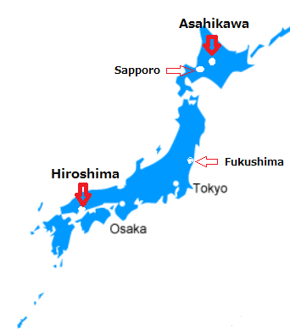
This booklet was created towards the 21st IPPNW World Congress.
English translation is due to Mr.Shimakura, a high school teacher in Asahikawa. I thank him deeply.

Nobuhiro Hagiwara

Asahikawa Clinic director
(Dohoku Medical Service for Workers Associatin)

A member of Hokkaido Physicians and Dentists Against Nuclear War (HPDANW)
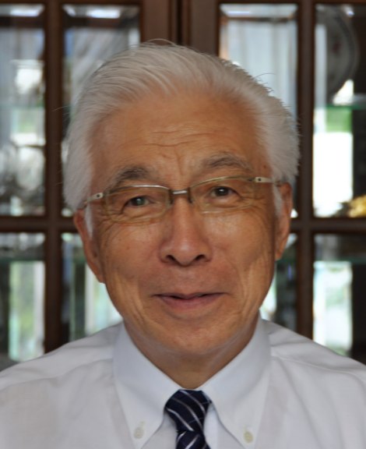
2-2-2 Toko 2 jo Asahikawa
078-8342 Japan
Hagiwara8338@kyf.biglobe.ne.jp

